How to Submit a Full Paper

Step 1: Login into the cdmHUB conference system at cdmhub.org/labs/run/ocs, you should see your papers listed, the ID is the paper number.
Step 2: You shall see # of your submissions listed between the Conference name. Click Author or # Active, you will enter the following page listed the abstracts you have submitted. Click AWAITING UPLOAD to enter Step 3 to UPLOAD SUBMISSION. 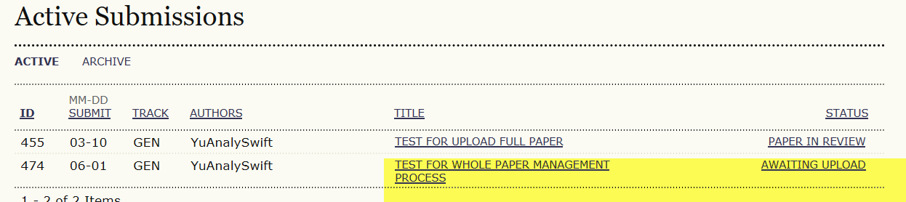

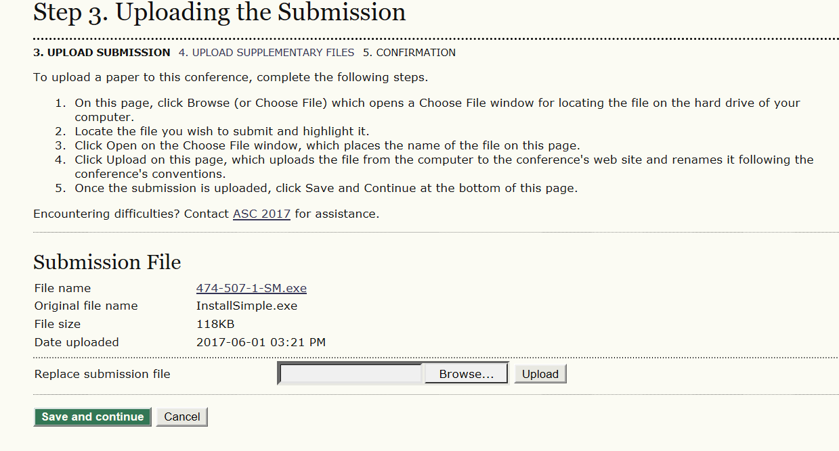
Step 3 Click Browse to open the file of your full paper you want to upload, then Click Upload. After done uploading, click Save and continue to enter Step 4 to upload Supplementary files

Step 4 Click Browse to open the file for Copyright Release Form signed by the lead author, then Click Upload. After done uploading, click Save and continue. It will bring up the Supplementary File Metadata page. Click Save and continue to skip this page. Then click Save and continue to finish uploading supplementary files and click Finish Submission to confirm your submission. The status of your submission should change to PAPER IN REVIEW.

