COVER SHEET
NOTE: This coversheet is intended for you to list your article title and author(s) name only
—this page will not appear on the CD-ROM.

Paper Number: 0228

Title: Micromechanical Modeling of Composites for Shear and Transverse Properties

Authors: Joshua Morris¹
Alireza Amirkhizi¹
Christopher Hansen¹

¹University of Massachusetts Lowell

ABSTRACT

An accurate micromechanical material model for predicting a composite’s elastic properties is desired in order to determine the potential structural and economic benefits of an advanced resin system for the construction of wind turbine blades. A MATLAB script and GUI are implemented for the determination of composite laminate properties based upon the properties of the individual matrix and reinforcement, as well as the fiber volume fraction. An advanced model based on periodic boundary conditions is compared with classical rule of mixture models and a composite cylinder model. The predicted properties of available systems are verified using a database of experimental results. This material model can be exported and used in finite element analysis to determine the structural effects and economic potential of a high performance resin (or reinforcement) with improved properties.

INTRODUCTION

Predicted composite properties from micromechanical models demonstrate good correlation to experimentally obtained values along the fiber direction (axial), but perform poorly in the shear mode and transverse direction, particularly for nearly uniaxial lay-ups such as those used predominantly in wind turbine blade manufacturing. The shear and transverse properties largely influence the torsional modes or trailing edge failures in blades. In an effort to gain an understanding of the shortcomings of traditional micromechanical models, a tool was developed to predict the composite properties and compare them to measured values. The new model being developed with enhanced property prediction capabilities would allow for greater confidence in the shear and transverse effects in wind turbine blades. From this, specialized resin systems or design changes can be implemented that would increase blade performance with regards to maximum tip deflection, trailing edge failure stress, reduction of blade mass, or an increase to blade length.

PLATFORM

The Composite Property Prediction Utility was developed within MATLAB 2015a using scripts to perform the calculations and GUIDE to create a user interface from which to control them. The program requires either an installed version of MATLAB or an installation of MATLAB Runtime (provided for free from MathWorks). Matlab Runtime can be used to distribute the tool to non-MATLAB users using a single installation file.

METHODS

The tool calculates the Axial Tensile Modulus E₁, Transverse Tensile Modulus E₂, and Axial Shear Modulus G₁₂ for the composite using the variation of the Rule of Mixtures (ROM) method outlined by Hyer (1998) [1] and the Composite Cylinder Model (CCM) outlined by Christensen (2012) [2]. The results are also compared with a Continuous Periodic Fiber Model (CPFM) described in Nemat-Nasser and Hori (1993) [3] and Nantasetphong (2016) [4]. Using either a basic averaging method or Classical Laminate Theory, the properties for a bidirectional composite layup are determined in order to compare with the measured data of tested composite specimens.
In the equations that follow, the subscript notations 1, 2, 3 denote the spatial coordinate with 1 being along the fiber length and the superscripts f, m denote the fiber and matrix respectively. The material assumptions made are for an isotropic matrix with a transversely isotropic fiber.

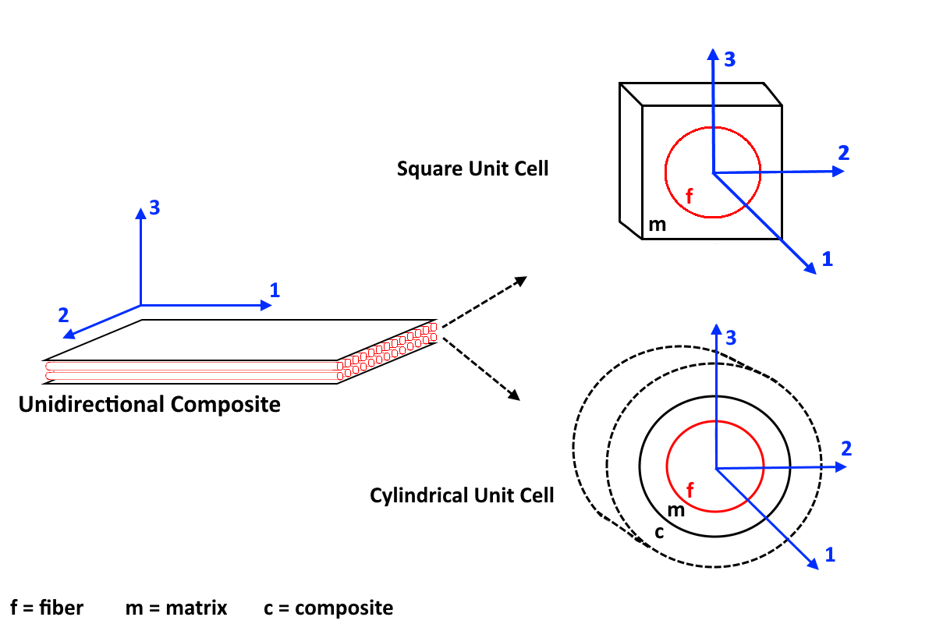
Figure 1: In the micromechanical models, the composite can be represented by a square unit cell (ROM and CPFM) or a cylindrical unit cell (CCM).

Rule of Mixtures Model (ROM): Detailed and Basic Forms

AXIAL TENSILE MODULUS, E₁

The axial modulus is calculated from an assumption that the strain in the fiber and matrix is equal in the direction of the fiber length and that the stress at the interface in the radial direction is equal. The model accounts for the differences in axial stress and the Poisson’s effect of the fiber and matrix. The formula for the ROM improved model of E₁ is provided as Equations 1a-c.

$E_{1}=E_{1}^{f}\left(1+γ\right)V^{f}+E^{m}\left(1+δ\right)\left(1-V^{f}\right)$ (1a)

$γ=\frac{2υ_{21}^{f}E^{m}\left(1-υ^{f}-2υ_{12}^{f}υ_{21}^{f}\right)V^{f}(υ_{12}^{f}-υ^{m})}{E_{2}^{f}\left(1+υ^{m}\right)\left(1+V^{f}\left(1-2υ^{m}\right)\right)+E^{m}(1-υ^{f}-2υ_{12}^{f}υ_{21}^{f})(1-V^{f})}$ (1b)

$δ=\frac{2E_{2}^{f}υ^{m}V^{f}\left(υ^{m}-υ_{12}^{f}\right)}{E_{2}^{f}\left(1+υ^{m}\right)\left(1+V^{f}\left(1-2υ^{m}\right)\right)+E^{m}(1-υ^{f}-2υ_{12}^{f}υ_{21}^{f})(1-V^{f})}$ (1c)

The ROM improved model for the axial tensile modulus can be simplified by assuming that the Poisson’s ratios of the fiber and matrix are equal ($ν_{12}^{f}=ν^{m}$) which makes both $γ$ and δ from Equations 1b-c identically 0. Equation 1a can be rewritten in the simplified form of Equation 2. This formulation is called the ROM basic axial tensile modulus model.

$E_{1}=E_{1}^{f}V^{f}+E^{m}(1-V^{f})$ (2)

TRANSVERSE TENSILE MODULUS, E₂

The ROM improved model for the transverse tensile modulus assumes that the stresses in the direction perpendicular to the fiber length are equal for the matrix and fiber. Similar to the axial tensile modulus, the Poisson’s effect and a difference in strains are considered to formulate Equations 3a-c for the composite effective E₂.

$E_{2}=\frac{E_{2}^{f}E^{m}}{η^{f}E^{m}V^{f}+η^{m}E_{2}^{f}(1-V^{f})}$ (3a)

$η^{f}= \frac{E_{1}^{f}V^{f}+[\left(1-{ν^{f}}^{2}\right)E^{m}+ν^{m}ν^{f}E_{1}^{f}](1-V^{f})}{E_{1}^{f}V^{f}+E^{m}(1-V^{f})}$ (3b)

$η^{m}= \frac{{[(1-{ν^{m}}^{2})E}_{1}^{f}-(1-ν^{m}ν^{f})E^{m}]V^{f}+E^{m}(1-V^{f})}{E_{1}^{f}V^{f}+E^{m}(1-V^{f})}$ (3c)

Similarly, from the assumption that the Poisson’s ratios of the materials are equal, a simplified form of the transverse tensile modulus can be written. In this case, η^{f} = η^{m} = 1 from Equations 3b-c and Equation 3a can be simplified to the form in Equation 4. This is called the ROM basic transverse tensile modulus model.

$E_{2}=\frac{E_{2}^{f}E^{m}}{{E^{m}V}^{f}+E_{2}^{f}(1-V^{f})}$ (4)

AXIAL SHEAR MODULUS, G₁₂

The ROM basic axial shear modulus model is similar to the ROM basic transverse tensile modulus model, with the assumption of equal shear stresses in the matrix and fiber. With consideration to the differences in strain for the fiber and matrix, Equation 5 is derived for the effective composite G₁₂.

$G_{12}=\frac{G^{m}G^{f}}{{G^{m}V}^{f}+G^{f}(1-V^{f})}$ (5)

Rule of Mixtures (ROM): Empirical Models

The transverse tensile modulus and axial shear modulus can be predicted using an empirical form based on an adjustment to the total effective volume of the composite, according the relationships in Equation 6a. These empirical constants are called stress partitioning factors and range from 0 < η or η′ < 1. This relationship is substituted in during the derivation of Equations 4-5 and yields the models for Equations 6a-b. A smaller η or η′ value indicates less contribution from the matrix to the overall composite properties, while a value of 1 would indicate that the models predict the modulus well without the need for an empirical constant. An empirical form for E₁ could also be derived, but the ROM basic and improved models provide good enough correlation to the measured data that an empirical model is not necessary.

${V_{tot}=V}^{f}+η V^{m} or {V_{tot}=V}^{f}+η'{ V}^{m}$ (6a)

$E_{2}=\frac{{E_{2}^{f}E^{m}(V}^{f}+η(1-V^{f}))}{E^{m}V^{f}+ηE_{2}^{f}(1-V^{f})}$ (6b)

$G_{12}=\frac{{G^{f}G^{m}(V}^{f}+η'(1-V^{f}))}{G^{m}V^{f}+η^{'}G^{f}(1-V^{f})}$ (6c)

Composite Cylinder Model (CCM)

The Composite Cylinder Model (CCM) generally provides better correlation to the measured data than the ROM solutions and is traditionally the preferred method for composite property prediction in practice. The models are determined by evaluating a three phase cylindrical unit cell which includes an effective medium region outside the resin and the fiber which represents the composite. The theory is based on the idea that, as the radial distance from the fiber and matrix origin increases, the exterior properties of the unit cell are best represented by those of the composite medium. This assumption results in the inclusion of material properties like the bulk modulus and shear modulus in the determination of the tensile moduli. The resin and fiber bulk moduli can be determined from the inputs using Equation 7.

$k=\frac{E_{1}}{3(1-2ν)}$ (7)

AXIAL TENSILE MODULUS, E₁

The axial tensile modulus combines the model from Equation 2 with a third term which represents the influence of the effective medium region. The difference in the resin and fiber Poisson’s ratios, shear moduli, and bulk moduli lead to a marginal improvement in the already fairly accurate ROM E₁ models. The CCM E₁ model is presented in Equation 8.

$E_{1}=V^{f}E^{f}+\left(1-V^{f}\right)E^{m}+\frac{4V^{f}\left(1-V^{f}\right){\left(ν^{f}-ν^{m}\right)}^{2}G^{m}}{\left[\frac{\left(1-V^{f}\right)G^{m}}{k^{f}+\frac{G^{f}}{3}}\right]+\left[\frac{V^{f}G^{m}}{k^{m}+\frac{G^{m}}{3}}\right]+1}$ (8)

TRANSVERSE TENSILE MODULUS, E₂

The CCM formulation for the transverse tensile modulus has a greater dependency on the properties of the effective medium region. Equation 9a for E₂ includes only properties of the effective medium, determined from calculations of the effective composite axial tensile modulus E₁, transverse shear modulus G₂₃, in-plane bulk modulus K₂₃, and Poisson’s ratio ν₁₂. These effective composite properties are calculated using Equations 9b-h.

$E_{2}=\frac{4G_{23}K_{23}}{K_{23}+G_{23}+4ν_{12}^{2}G_{23}K_{23}/E_{1}}$ (9a)

$K_{23}=k^{m}+\frac{G^{m}}{3}+\frac{V^{f}}{\frac{1}{\left[k^{f}-k^{m}+\frac{1}{3}\left(G^{f}-G^{m}\right)\right]}+\frac{1-V^{f}}{k^{m}+\frac{4}{3}G^{m}}}$ (9b)

$ν_{12}=\left(1-V^{f}\right)ν^{m}+V^{f}ν^{f}+\frac{V^{f}\left(1-V^{f}\right)\left(ν^{f}-ν^{m}\right)\left[\frac{G^{m}}{k^{m}+\frac{G^{m}}{3}}+\frac{G^{m}}{k^{f}+\frac{G^{f}}{3}}\right]}{\left[\frac{\left(1-V^{f}\right)G^{m}}{k^{f}+\frac{G^{f}}{3}}\right]+\left[\frac{V^{f}G^{m}}{k^{m}+\frac{G^{m}}{3}}\right]+1}$ (9c)

The transverse shear modulus G₂₃ calculation, which is needed to calculate E₂ is not derived directly from the CCM solution, unlike the in-plane bulk modulus bulk modulus and Poisson’s ratio. Instead a suitable substitution suggested by Christensen [2] is used. A second order model is implemented with the coefficients in Equation 9e-h, where the first positive root of Equation 9d is used to determine the value of G₂₃.

$A{\left(\frac{G_{23}}{G^{m}}\right)}^{2}+2B\left(\frac{G_{23}}{G^{m}}\right)+C=0$ (9d)

$A=3V^{f}{\left(1-V^{f}\right)}^{2}\left(\frac{G^{f}}{G^{m}}-1\right)\left(\frac{G^{f}}{G^{m}}+η^{f}\right)+\left[\frac{G^{f}}{G^{m}}η^{m}+η^{m}η^{f}-\left(\frac{G^{f}}{G^{m}}η^{m}-η^{f}\right){V^{f}}^{3}\right]*\left[V^{f}η^{m}\left(\frac{G^{f}}{G^{m}}-1\right)-\left(\frac{G^{f}}{G^{m}}η^{m}+1\right)\right]$ (9e)

$B=-3V^{f}{\left(1-V^{f}\right)}^{2}\left(\frac{G^{f}}{G^{m}}-1\right)\left(\frac{G^{f}}{G^{m}}+η^{f}\right)+\frac{1}{2}\left[\frac{G^{f}}{G^{m}}η^{m}+\left(\frac{G^{f}}{G^{m}}-1\right)V^{f}+1\right]*\left[\left(η^{m}-1\right)\left(\frac{G^{f}}{G^{m}}+η^{f}\right)-2\left(\frac{G^{f}}{G^{m}}η^{m}-η^{f}\right){V^{f}}^{3}\right]+\frac{V^{f}}{2}\left(η^{m}+1\right)\left(\frac{G^{f}}{G^{m}}-1\right)\left[\frac{G^{f}}{G^{m}}+η^{f}+\left(\frac{G^{f}}{G^{m}}η^{m}-η^{f}\right){V^{f}}^{3}\right]$ (9f)

$C=3V^{f}{\left(1-V^{f}\right)}^{2}\left(\frac{G^{f}}{G^{m}}-1\right)\left(\frac{G^{f}}{G^{m}}+η^{f}\right)+\left[\frac{G^{f}}{G^{m}}η^{m}+\left(\frac{G^{f}}{G^{m}}-1\right)V^{f}+1\right]*\left[\frac{G^{f}}{G^{m}}+η^{f}+\left(\frac{G^{f}}{G^{m}}η^{m}-η^{f}\right){V^{f}}^{3}\right]$ (9g)

$η^{m}=4-3ν^{m} and η^{f}=3-3ν^{f}$ (9h)

AXIAL SHEAR MODULUS, G₁₂

The composite axial shear modulus is less dependent on the properties of the CCM in the effective medium region, and has the relatively simple form of Equation 10. This form demonstrates a strong influence from the shear modulus of the matrix material on the effective composite axial shear modulus.

$G_{12}=G^{m}\left\{\frac{\left(G^{m}+G^{f}\right)-V^{f}(G^{m}-G^{f})}{\left(G^{m}+G^{f}\right)+V^{f}(G^{m}-G^{f})}\right\}$ (10)

Continuous Periodic Fiber Model (CPFM)

The CPFM calculates the effective elasticity and compliance tensors of the composite which are used to determine the engineering properties. The uniform applied strain/stress are shown as $(ε^{0}, σ^{0})$ and the average strain/stress over the total volume of the composite $(\overline{ε}, \overline{σ})$. When strain is applied to a representative volume element, then $\overline{ε}=ε^{0}$. The similar equation exists for stresses when the uniform traction is applied over the boundary. The overall constitutive elasticity, $\overline{C}$, and compliance, $\overline{D}$, tensors of the composite are written as a distribution of the applied stress and strain through the fiber volume fraction. For uniform applied boundary displacement and tractions, one gets (11) and (12), respectively.

$\overline{C}:ε^{0}=C^{m}:ϵ^{0}+V^{f}\left(C^{f}-C^{m}\right):{\overline{ε}}^{f}$ (11)

$\overline{D}:σ^{0}=C^{m}:σ^{0}+V^{f}\left(D^{f}-D^{m}\right):{\overline{σ}}^{f}$ (12)

The relationship between the applied strain/stress and the strain/stress carried by the fiber is generally unknown and written based on transformation tensors P and Q.

${\overline{ε}}^{f}=P^{f}:ε^{0} {\overline{σ}}^{f}=Q^{f}:σ^{0}$ (13)

$\overline{C}=C^{m}+V^{f}\left(C^{f}-C^{m}\right):P^{f}$ (14)

$\overline{D}=C^{m}+V^{f}\left(D^{f}-D^{m}\right):Q^{f}$ (15)

The transformation tensor P is determined for a periodic, cylindrical, uniaxially aligned, short fiber following Nemat-Nasser and Hori (1998). The formulation incorporates a fourth order tensor similar to Eshelby’s Tensor, S^{P}, which includes a Fourier series representation of the field variables.

$P^{f}={\left(C^{m}-C^{f}\right)}^{-1}:C^{m}:{\left({\left(C^{m}-C^{f}\right)}^{-1}:C^{m}-S^{P}\right)}^{-1}$ (16)

For details see Nantasetphong et al. (2016). Substituting Equation 16 into 14 allows for the calculation of the elasticity tensor of the effective composite. It is not necessary to formulate the transformation tensor, Q, for the composite compliance due the periodicity and geometry of the chosen unit cell. In this case, the compliance, $\overline{D}$, is exactly the inverse of the elasticity tensor, $\overline{C}$.

$\overline{C}=C^{m}-V^{f}C^{m}:{\left({\left(C^{m}-C^{f}\right)}^{-1}:C^{m}-S^{P}\right)}^{-1}={\overline{D}}^{-1}$ (17)

From the effective composite compliance tensor, various engineering properties of the composite can be extracted, explicitly the axial tensile, transverse tensile, and axial shear moduli.

$\left[D_{axial}\right]=\left[\begin{matrix}\begin{matrix}1/E_{1} & -ν_{12}/E_{1} & -ν_{12}/E_{1} \\ -ν_{12}/E_{1} & 1/E_{2} & -ν_{23}/E_{2} \\ -ν_{12}/E_{1} & -ν_{23}/E_{2} & 1/E_{2}\end{matrix} & 0 \\ 0 & \begin{matrix}1/G_{23} & 0 & 0 \\ 0 & 1/G_{12} & 0 \\ 0 & 0 & 1/G_{12}\end{matrix}\end{matrix}\right]$ (18)

Layup Calculations

CLASSICAL LAMINATE THEORY

For nearly unidirectional laminates used in wind turbine manufacturing with calculated values for E₁, E₂, and G₁₂, the results may be improved using Classical Laminate Theory. After determination of the unidirectional composite properties, compliance tensors for the axial and transverse directions can be formed with Equation 19 where [D_{transverse}] is a permutation of [D_{axial}]. The CPFM calculation includes a determination of the full compliance tensor, which can be permuted in a similar manner. This permutation is possible since the fibers in these lay-ups are perpendicular, otherwise, full rotation transformation will become necessary.

$\left[D_{transverse}\right]=\left[\begin{matrix}\begin{matrix}1/E_{2} & -ν_{12}/E_{1} & -ν_{23}/E_{2} \\ -ν_{12}/E_{1} & 1/E_{1} & -ν_{12}/E_{1} \\ -ν_{23}/E_{2} & -ν_{12}/E_{1} & 1/E_{2}\end{matrix} & 0 \\ 0 & \begin{matrix}1/G_{12} & 0 & 0 \\ 0 & 1/G_{23} & 0 \\ 0 & 0 & 1/G_{12}\end{matrix}\end{matrix}\right]$ (19)

For the CCM model, G₂₃ and ν₁₂ are previously determined using Equations 9c-h. The ROM models use Equations 20a-b, which are derived similarly to the ROM basic forms. Both scenarios incorporate a transverse Poisson’s ratio ν₂₃ calculated using Equation 20c, which includes the unidirectional composite transverse tensile modulus and transverse shear modulus.

$G_{23}=\frac{G_{23}^{f}G^{m}}{{G^{m}V}^{f+}G_{23}^{f}(1-V^{f})}$ (20a)

$υ_{12}=υ_{12}^{f}V^{f}+υ^{m}(1-V^{f})$ (20b)

$ν_{23}=\frac{E_{2}}{2G_{23}}-1$ (20c)

The inverse of each compliance tensor yields an elasticity tensor for the composite in the axial and transverse directions. The elasticity tensors can be combined using the proportions of fibers in the layup to produce a single elasticity tensor for the composite. This method is presented as Equation 21. By taking the inverse of the composite elasticity tensor, [C_{composite}], and the compliance tensor term relationships from Equation 18, the effective bidirectional composite moduli can be determined. Here $X=1-Y$ is the fraction of fiber in each of the two directions.

${\left[D_{composite}\right]={\left[C_{composite}\right]}^{-1}=\left[X{\left[D_{axial}\right]}^{-1}+Y{\left[D_{transverse}\right]}^{-1}\right]}^{-1}$ (21)

TOOL INPUTS

The composite properties are calculated from inputs of the individual fiber and matrix properties as well as the volume fraction of the composite. Greater functionality of the tool can be appreciated if measured data is available for comparison and the material databases for resins, fibers, and experimental data are edited prior to execution. The entry fields for the inputs are marked in Figure 2.
A minimum of five input values, including the fiber volume fraction, are needed to operate the tool at its most basic functionality using the Custom Properties setting. The properties for the matrix and fiber required are two of the following for each material: the Axial Tensile Modulus E₁, Poisson’s Ratio ν, and Axial Shear Modulus G₁₂. The third value for each material can be left blank and will be determined from the other two upon execution of the code using manipulations of Equation 22.

$G_{12}=\frac{E_{1}}{2(1+ν)}$ (22)

The tool also utilizes spreadsheet catalogs of resin and fiber properties to load drop down lists with the available resin/fiber systems and automatically populates the input properties fields when one is selected. Once a selection of a resin and fiber has been made, a third catalog with experimentally determined properties is checked for a matching material system and the measured properties fields are automatically populated with the available data. New resins can be added to these catalogs and imported directly into the tool.
A layup adjustment interface is incorporated to accommodate laminates with bidirectional [0/90]_{s} layups, since composites listed as unidirectional often contain small portions of transversely aligned stabilizing layers that affect the overall laminate performance. To utilize this feature, knowledge of the percentage of fibers in the axial and transverse directions is needed.

OUTPUTS

After the Calculate button is pressed, the output of the tool displays the composite Axial Tensile Modulus E₁, Transverse Tensile Modulus E₂, and Axial Shear Modulus G₁₂ along with the associated percentage difference with the experimental results (if available). An example of the outputs for a successfully run material system are shown in Figure 2.

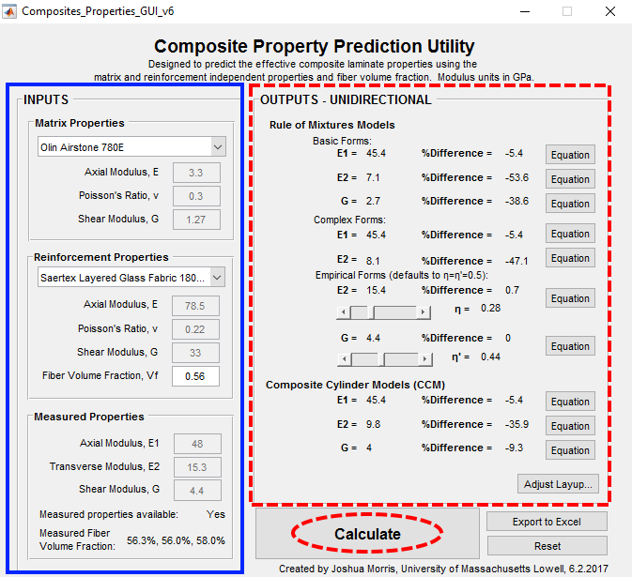
Figure 2: The inputs field of the tool (marked by the solid box) for entering the resin, fiber, and measured composite properties (if available) along with the outputs field of the tool (marked by the dashed box). The output displays the Axial Tensile Modulus E₁, Transverse Tensile Modulus E₂, and Axial Shear Modulus G₁₂ as determined by the various micromechanical material models.

An empirical model has been included which implements stress partitioning factors, η and η′. The sliders within the outputs section of the tool adjust the stress partitioning factors and display the model errors as changes are made. The value of these empirical factors can provide insight into the individual contributions of the matrix and reinforcement to the overall composite properties. These factors are discussed in greater detail within the Methods and Conclusions sections.
The formulas and references for each of the micromechanical methods can be seen by pressing the Equation button located next to each output property. An example of this feature is noted by Button 1 in Figure 3. This functionality allows for a better visualization of the differences between the models and a better understanding of the error sources.
The percent difference for each predicted moduli are determined by comparing the predicted value to the measured value provided during the input process. The result will read NaN if the measured property is not provided for a particular modulus. A negative percent difference indicates that the property has been under predicted and a positive value indicates over prediction. The properties determined by this tool are for a truly unidirectional composite and an additional tool for determining bidirectional layup effects can be opened by selecting Adjust Layup. This feature is noted by Button 2 in Figure 3.

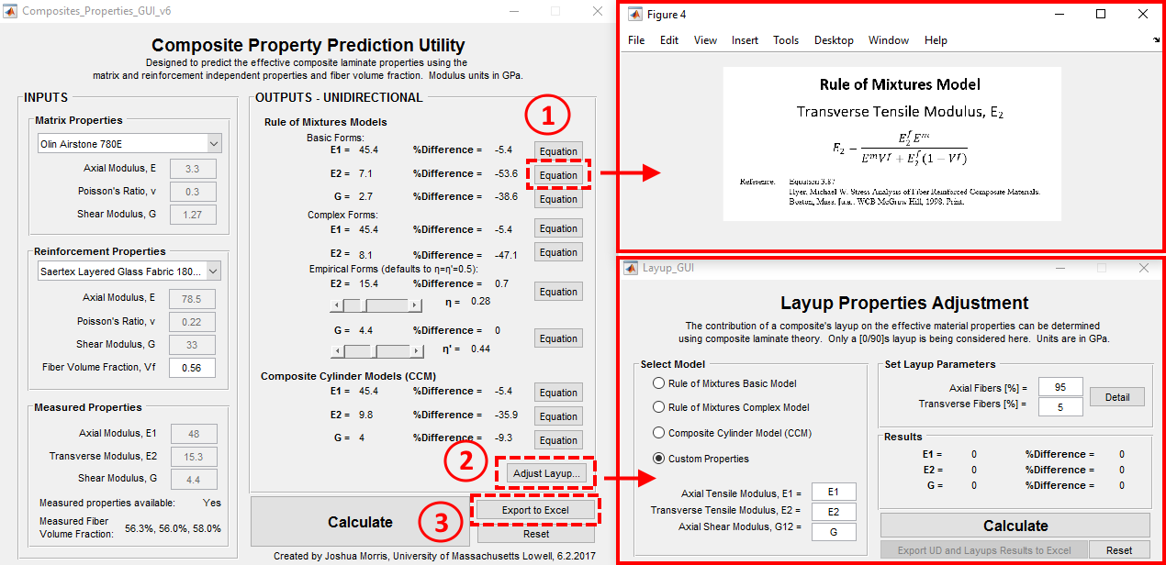
Figure 3: From the outputs section, the theory of the models can be viewed (Button 1) or the layup adjustment window can be opened (Button 2). The inputs and results without the layup adjustment can be exported to a spreadsheet (Button 3).

The Layup Properties Adjustment window can load the properties determined in the Composite Property Prediction Utility for a unidirectional layup and adjust them for a known percentage of fibers in the axial and transverse directions. A model selection made using the radio buttons automatically populates the input properties fields or user defined Custom Properties can be entered instead. Two methods for layup adjustment are utilized which depend on whether a shear property is provided. Both the axial and tensile modulus must be input in order to do a layup adjustment. The theory can be viewed by pressing Button 1 in Figure 4.

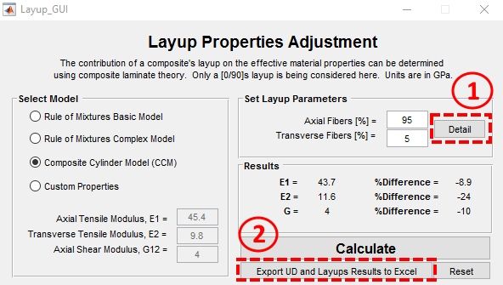
Figure 4: The theory of the layup adjustment can be viewed (Button 1). The unidirectional and bidirectional layup results can be exported (Button 2).

The results can be saved as .xls format from either the Composite Property Prediction Utility (Button 3 in Figure 3) or Layup Properties Adjustment window (Button 2 in Figure 4). Saving from the Composite Property Prediction Utility will only save the unidirectional results whereas saving from the Layup Properties Adjustment window will save both the unidirectional and bidirectional results. Upon pressing either button, a “Save as…” dialog box will open and the user will be prompted to select a file path.

TABLE 1: Resulting model errors from an example calculation for the system of Olin Airstone 780E resin with Saertex Layered Glass Fabric at a volume fraction of 56% and a layup of 95% of the fibers in the axial direction.
Model | E₁  %Difference | E₂ %Difference | G₁₂  %Difference
ROM Basic Unidirectional | -5.4 | -53.6 | -38.6
ROM Improved Unidirectional | -5.4 | -47.1 | N/A
CCM Unidirectional | -5.4 | -35.9 | -9.3
CCM Bidirectional | -8.9 | -24.0 | -9.1
CPFM Bidirectional | -8.8 | -13.4 | -8.0

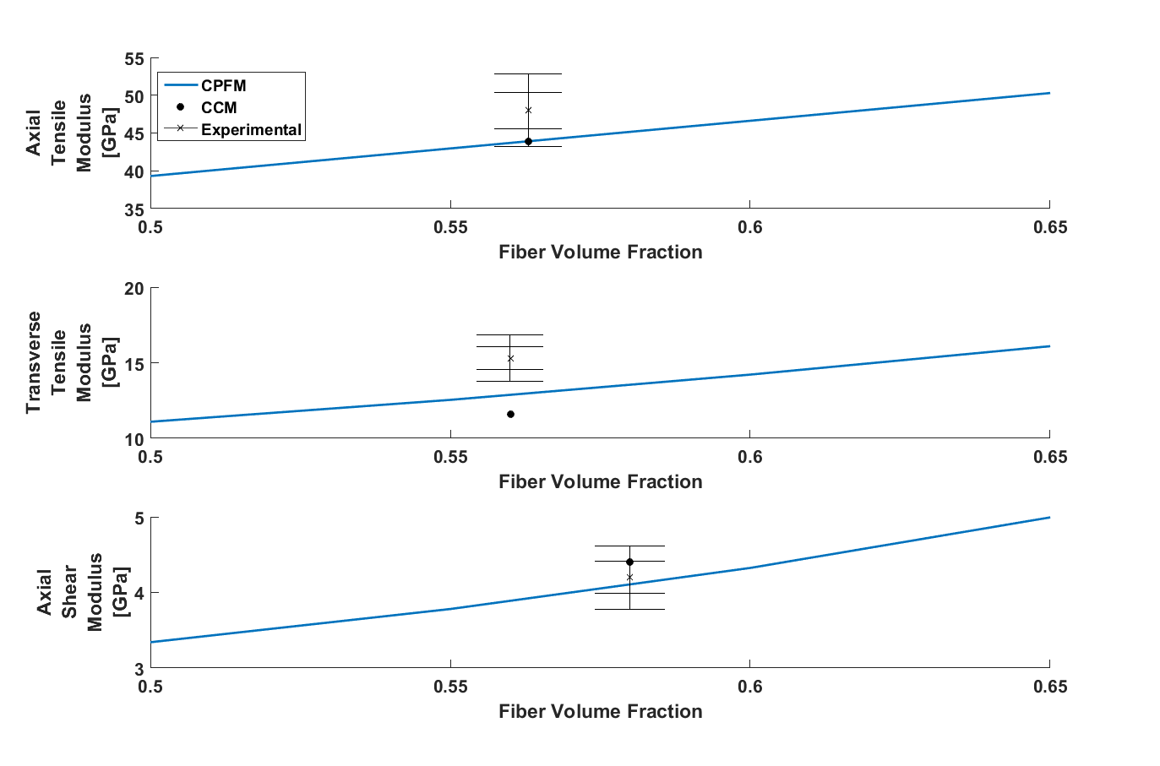
Figure 5: The axial tensile modulus E₁, transverse tensile modulus E₂, and axial shear modulus G₁₂ for the example material system at fiber volume fractions from 50-75% for the CPFM model. The CCM results and experimental values (with error bars at ±5 and ±10%) are included for comparison.

TYPICAL RESULTS AND DISCUSSION

The tool allows for the quick determination of effective composite laminate properties for a provided material system. An example was run for a system of Olin Airstone 780E resin with Saertex Layered Glass Fabric at a volume fraction of 56% and a layup of 95% of the fibers in the axial direction. Measured data was available for comparison; with experimental volume fractions of 56.3%, 56.0%, and 58.0%. The results of the example material system are displayed in Table 1. The empirical models are useful for observing how the models could be improved, but an empirical solution is undesirable so these results are excluded in the discussion of the example system.
The Axial Tensile Modulus E₁ prediction accuracy does not vary until the bidirectional layup is considered. It was under-predicted by -5.4% for all models. The bidirectional layup properties were determined for CCM and CPFM with axial modulus differences increasing to -8.9% and -8.8% respectively, due to the loss of 5% of the fibers in the axial direction.
The Transverse Tensile Modulus E₂ fluctuates greatly between models. The ROM basic model has the highest deviation of -53.6%. The additional considerations of different Poisson responses in the resin and fiber result in a reduced value in the ROM improved model to -47.1%. The CCM adds the influence of a third phase representing the mixed medium which reduces the deviation of the transverse tensile modulus to -35.9%. The considerations of the bidirectional layup properties further improved the CCM transverse modulus difference to -24.0% resulting from the addition of stabilization fibers aligned with the transverse direction. With the inclusion of effects from fiber interactions and periodicity the bidirectional CPFM accuracy improves to just -13.4% difference.
The Axial Shear Modulus G₁₂ has an error of -38.6% for the ROM basic model, which does not consider a difference in Poisson’s effects or material interactions. The CCM shifts the formula to be heavily dependent on the matrix shear properties which reduces the difference to -9.3%. The bidirectional layup considerations for the CCM cause a slight change to -9.1%, demonstrating that the shear modulus is less dependent on the layup than the other properties. The CPFM, with layup accounted for, improves the difference to -8.0%, due to considerations of the fiber interactions and periodicity.
The CPFM solution for the bidirectional example material system is plotted for a fiber volume fraction range of 50-75% in Figure 5. The experimental results are displayed with deviation bars at 5% and 10% intervals, along with the CCM results at the same volume fraction as the experimental data for comparison. Both the axial tensile and shear moduli are within 10% of the experimental values. The transverse tensile modulus accuracy is still outside of the desired range, but the CPFM shows great improvement in comparison to the next closest traditional material prediction model. With continued work, the results of the CPFM may be further improved by changing the structure of the model from a square lattice (present results) to a hexagonal closed-pack, which represents the fiber arrangements more realistically.

CONCLUSIONS

When used our computational tool on a large database of resins, fibers, and measured composite properties and demonstrated where improvements to the predictions of the transverse and shear models can be made. The predictions of the advanced micromechanical model (CPFM) have been compared with the traditional methods in this GUI. With an improved prediction of composite properties, materials developers and blade designers can guide their efforts in a direction that benefits the overall performance or cost of wind turbine blades.

ACKNOWLEDGEMENTS

This material is based upon work supported by the National Science Foundation under Grant Number IIP-1362022 (Collaborative Research: I/UCRC for Wind Energy, Science, Technology, and Research). Any opinions, findings, and conclusions or recommendations expressed in this material are those of the author(s) and do not necessarily reflect the views of the National Science Foundation. The authors would like to thank the WindSTAR Company Members (Aquanis Inc., EDP Renewables, Bachmann Electronic Corp, GE Energy, Huntsman, Hexion, Leeward Asset Management, LLC, Pattern Energy, TPI Composites Inc.) for funding this research.
The authors wish to thank WindSTAR IAB members Hui Zhou, Marc Chouinard, Robert Grigsby, and David Lee (Huntsman), Steve Nolet and Tim Fallon (TPI Composites), and Nicholas Althoff (GE Renewables) for their time and contributions in guiding this project.

REFERENCES

- M. W. Hyer and S. R. White, Stress Analysis of Fiber-reinforced Composite Materials. WCB McGraw-Hill, 1998.
- R. M. Christensen, Mechanics of Composite Materials. Courier Corporation, 2012.
- S. Nemat-Nasser and M. Hori, Micromechanics: Overall Properties of Heterogeneous Materials. Elsevier, 1993.
- W. Nantasetphong, A. V. Amirkhizi, Z. Jia, and S. Nemat-Nasser, “Dynamic properties of polyurea-milled glass composites Part II: Micromechanical modeling,” Mechanics of Materials, vol. 98, pp. 111–119, Jul. 2016.

