2.2 Square Pack Microstructure (2D SG)
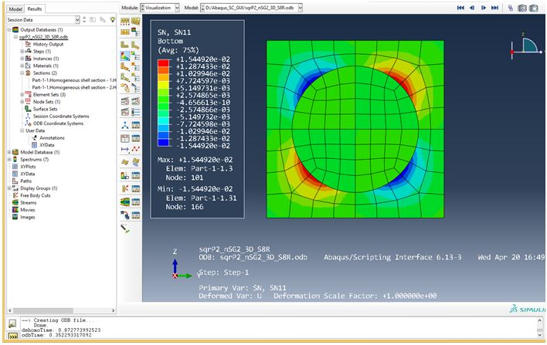
Fig given in manual

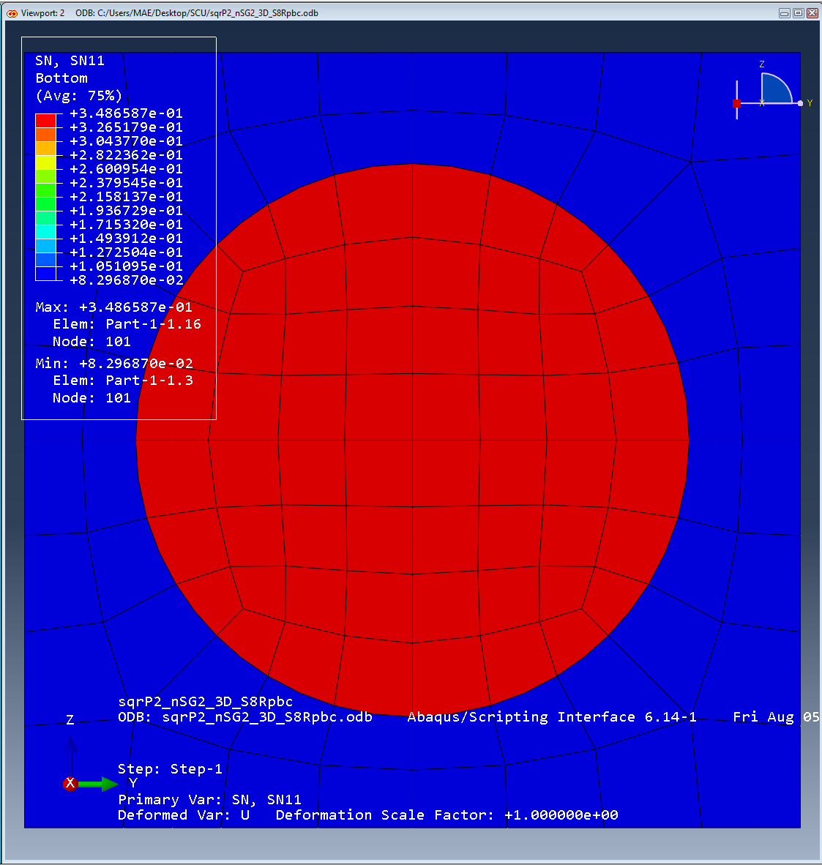
Fig that is I am finding

