COVER SHEET

Paper Number: 288

Title: A Code for Flexural Analysis of Thin-Walled Composite I-Beams with Sandwich Web and Bond-lines

Authors :
Mohamad Eydani Asl
Christopher Niezrecki
James Sherwood
Peter Avitabile

(FIRST PAGE OF ARTICLE – align this to the top of page – leave space blank above ABSTRACT)

ABSTRACT

Composite I-beams have extensive applications in the aerospace industry, construction and light-weight engineering structures. In the utility-scale wind turbine blades, the spar-caps and the shear web compose an I-beam structure which is referred to as the backbone of the blade carrying the majority of the induced aerodynamic loads induced to the blade. To assess the flexural properties of the composite I-beam replicating the spar-caps and the shear web geometry of a utility-scale wind turbine blade, a Matlab code is developed. The code evaluates the flexural and shear stiffnesses of a thin-walled laminated composite I-beam based on the shear-deformable beam theory and predicts the strain and displacement fields of the beam based on the prescribed load and boundary conditions. The developed code enables fast parametric assessments for design and optimization of the structurally critical region of the utility-scale wind turbine bales. The code inputs are the material properties and geometry of the laminated flanges, sandwich web (face sheets and foam core) and adhesive paste between the web and the flanges. The outputs are shear stiffness, flexural stiffness, and strain and displacement fields along the length span of the blade for various boundary conditions. The code is verified using ABAQUS finite element software and validated using experimental data for flexural bending of a laminated composite I-beam in a three-point bending test configuration.

_____________
Mohamad Eydani Asl
Christopher Niezrecki
James Sherwood
Peter Avitabile
Department of Mechanical Engineering, University of Massachusetts Lowell, One University Avenue, Lowell, Massachusetts 01854
MATHEMATICAL MODEL
The governing equations for flexural bending of a laminated composite I-beam are introduced in this section. The closed form solutions for deflection and normal strain distribution for an I-beam geometry shown in Figure 1 in a three-point bending configuration are derived.
The governing equations for flexural bending of the shear-deformable laminated I-beam in the absence of any coupling effects, with respect to x-axis are given by [1]:

 | $${{(GA}_{x})}_{com}( V^{''}+{Ψ^{'}}_{x})=p$$  $${{(EI}_{x})}_{com}{Ψ^{''}}_{x}-{{(GA}_{x})}_{com}( V^{'}+Ψ_{x})=0$$ | (1a)  (1b)

Where p is the point load, V indicates the displacement in y direction and the symbol $Ψ_{x}$ is the rotation of the cross-section with respect to x-axis as shown in Figure 1. The prime $(^{'})$ indicates differentiation with respect to z-axis. The symbols ${{(GA}_{x})}_{com}$ and ${{(EI}_{x})}_{com}$ denote the shear and flexural stiffnesses of the laminated composite with respect to x-axis, respectively. The terms ${{(EI}_{x})}_{com}$ and ${{(GA}_{x})}_{com}$ are general expressions for arbitrary cross sections and depend on the cross-section geometry of the composites. Assuming the thin wall does not deform in its own plate and the Kirchhoff-Love assumption in classical plate theory remains valid for laminated composite thin-walled beams, For I-section shapes, the explicit expressions may be derived using a variational formulation as described in[1]:

 | $${{(EI}_{x})}_{com}=\left[A_{11}^{α} y_{α}^{(2)}-2B_{11}^{α} y_{α}+D_{11}^{α}\right]b_{α}+\frac{b_{3}^{(3)}}{12}A_{11}^{3}$$  $${{(GA}_{x})}_{com}=A_{55}^{α}b_{α}+A_{66}^{3}b_{3}$$ | (1c)  (1d)

where $A_{11},A_{66},A_{55},B_{11}$ and $D_{11}$ indicate the extensional, coupling and bending stiffness coefficients for a laminated composite layup. The repeated indices indicate the summation and the superscript in the parenthesis ( ) is the power of the exponent. The symbol $α$ is a summation index varying from 1 to 4 where the indices 1 and 2 indicate the top and bottom flanges, index 3 is for the shear web and 4 for the bond-line, respectively as shown in Figure 1 and $b_{α}$ represents width of the top and bottom flanges and the web. The extensional, coupling and bending stiffness coefficients $A_{ij}, B_{ij} and D_{ij}$ for a laminated plate are defined as the following:

 | $${(A}_{ij}, B_{ij}, D_{ij})=\int_{-\frac{h}{2}}^{\frac{h}{2}}{{\overline{Q}}_{ij}}\left(1, z, z^{2}\right)dz=\sum_{k=1}^{N}{\int_{z_{k}}^{z_{k+1}}{{{\overline{Q}}_{ij}}^{(k)}}\left(1, z, z^{2}\right)dz}$$ | (1e)

Where ${\overline{Q}}_{ij}$ are the transferred plane stress-reduced stifnesses, h denotes the laminate thickness and N is the total number of the plies. The closed-form solution of the normal strain $ε_{zz}$ and transverse deflection for the uncoupled Eq. (1a) and Eq. (1b) can be derived for the concentrated point load and simply-supported boundary condition as [1]:

 | $$ε_{zz}=\frac{pyz}{2{{(EI}_{x})}_{com}}$$ | (2a)
 | $$υ_{0}(z)=\frac{{pl}^{3}}{48{{(EI}_{x})}_{com}}[3\left(\frac{z}{l}\right)-4{\left(\frac{z}{l}\right)}^{3}]+ \frac{pl}{2{{(GA}_{x})}_{com}}\left(\frac{z}{l}\right)$$ | (2b)

In Eq. (2b), the first and second terms represent the deflection by Euler beam theory and the deflection due to shear deformability, respectively.

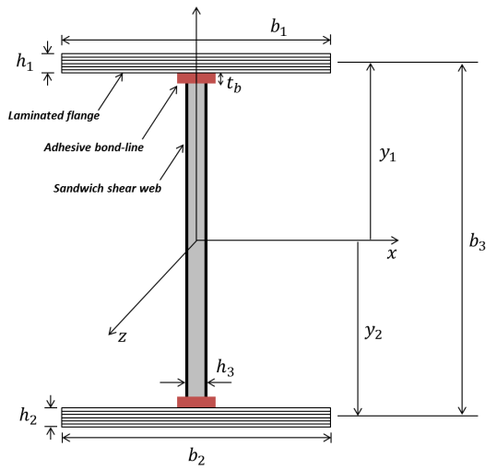
Figure 1. The schematic of the I-beam geometry with the laminated flanges, sandwich shear web and bond-lines.

VERIFICATION AND VALIDATION
For validation of the developed code, three identical I-beams were designed, manufactured and loaded in a quasi-static three-point bending configuration. The designed I-beams had an overall dimension overall dimension of 58.6 cm × 4.93 cm × 3 cm with ${[0] }_{2 }$layup for the flanges as shown in Figure 2. The flanges were made from the unidirectional glass/epoxy materials, and the shear web was constructed from a foam core wrapped in a $±45$ ply of glass/epoxy. The flanges and the shear web were carefully bonded together using the adhesive paste and were cured while the adhesive thickness throughout the length of the beams were controlled using a fixture. The manufactured specimens were loaded in a three-point bending test configuration to investigate the correlation of their strain and displacement fields with the analytical solution and finite element simulation.

Figure 2. (Left): The three manufactured I-beams each consisting of two flanges made of unidirectional glass/epoxy materials and a sandwich shear web constructed from a foam core wrapped in a $±45$ ply of glass/epoxy. (Right): The flanges and the web were bonded together using the adhesive paste with a consistent adhesive thickness throughout the length of the beams.

For verification of the developed code, a finite element analysis was pursued. For the finite element analysis Abaqus version 6.13 was used. The beam was modeled using the doubly-curved general purpose shell element S8R with reduced integration. The model was discretized with 7500 nodes with the approximate characteristic length element of 0.003m. The displacement of the bottom flange elements were restrained at the support locations in the direction of the applied load. As shown in Figure 3, a path was defined along the bottom flange of the beam to extract the strain and displacement values to be compared to the experimental and analytical values. The distance of the supports from the free ends of the beam was 25.5 mm identical to that of the experimental setup. A static load was applied in four increments from 222.4 N to 7778.5 N (i.e. 50 lbs to 175 lbs) identical to the loads applied to the analytical model and the loaded beams in the experiment. All computations are implemented for the glass/epoxy materials with following material characteristics [2]: $E_{1}=41.8$ GPa, $E_{2}=E_{3}=14$ GPa, $G_{12}=G_{13}=2.63$ GPa, $G_{23}=1.83$ GPa, $υ_{12}=υ_{13}=0.28$, $υ_{23}=0.47$.

Figure 3. The Designed scaled model was loaded in a three-point bending configuration in four increments from 222.4 N to 7778.5 N and displacement and strain values were extracted from the defined path on the bottom flange of the beam (red dotted line).

Strain Field

The I-beams were loaded in a three-point test setup with incremental static loads while DIC cameras were used to measure the full-field strain distribution and displacement in the bottom flange of the I-beams as shown in Figure 4. The I-beams were loaded in four quasi-static increments from 222.4 N to 778.5 N (i.e. 50 lbs to 175 lbs ), and the full-field normal strain in the bottom flange of the I-beams was recorded for each stage. The flanges of the I-beam were the best candidates for the strain measurement because they exhibit the highest level of strain compared to other regions of the beam. The applied-load steps were adjusted to generate strain levels in the flanges high enough to be captured by the cameras while remaining to be in the elastic range but far enough away from loading levels that could induce cracking and subsequent beam failure. The noise floor for the normal strain $ε_{zz}$ during the measurement was $±20 μm/m$ and $±0.002 mm$ for the transverse displacement. Because the primary purpose of the experiment was to investigate the accuracy of the developed code from a formulation valid for the linear elastic bending, the beams were loaded in their elastic bending region to keep the governing equations valid for the entire study.

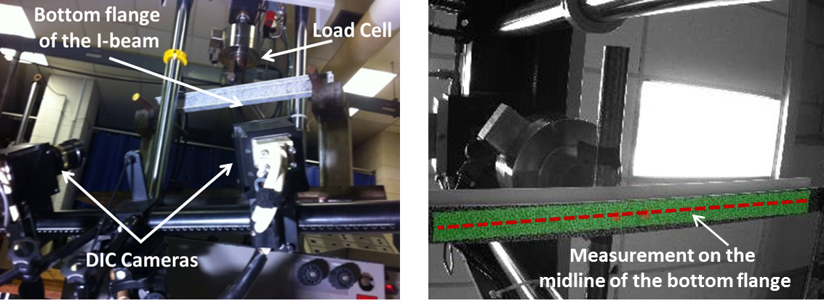

Figure 4. Three-point bend test: (Left) Three-point bending test configuration of the designed I-beam for the full-field strain measurement using DIC cameras. (Right) Strain and displacement values for transverse deflection of the I-beam were selected from the midline of the bottom flange of the I-beam.

The average of the three experimental strain results was compared to the code prediction (referred to as the analytical model) and to Abaqus finite element model. Figure 5 shows the normal strain values in the bottom flange of the I-beam for the analytical model, the Abaqus simulation and the experimental data. Each solid line represents a prescribed load in the analytical model, the associated dashed line and data points denote the Abaqus solution and the experimental data, respectively. From the results shown in Figure 5, it can be concluded that there is good correlation for the normal strain values among the three approaches. The degree of correlation between the experimental and simulation results increases as the load increases. This increase is correlation is because the effect of the noise floor on the measurement decreases as the level of strain increases.

Figure 5. Comparison of the normal strains in the bottom flange of the designed I-beam
for different prescribed loads in a three-point bending test configuration.
Displacement field

To investigate the accuracy of the developed code in predicting the displacement field of the composite I-beams, a comparison between the displacement fields of the loaded beam, code output and the finite element model was pursued. The transverse deflection for the bottom flange of the designed beam was measured using the same test setup using DIC cameras as shown in Figure 4 and applied loads described in the previous section. The measured deflection of the bottom flange of the beam along its length span was compared to the code output (referred to as the analytical model) and finite element model as shown in Figure 6. A very good correlation between measured data, the finite element and analytical models can be observed especially for the two highest loading stages (i.e. P=666 N and P=777 N). As the load increases, the correlation between experimental data and analytical data improves because the effect of the noise floor on the measured displacement field decreases for larger deflections.

Figure 6. Comparison of the transverse deflection of the bottom flange of the designed I-beam for different prescribed loads in a three-point bending test configuration.

CONCLUSIONS

In this paper, a code was developed for the flexural bending of a composite laminated I-beam geometry. The code inputs were the material properties for the flanges, shear web and the adhesive bond-line and the outputs were the flexural stiffness, strain and displacement fields of the beam. To validate the code, three identical beams were manufactured from the same drawing and loaded in a quasi-static three-point bending test. Moreover, a finite element model was developed for the tested beams for verification purposes. The strain and displacement fields of the loaded beams were compared to the code outputs and finite element predictions. Based on the results, a good correlation between the code outputs, the finite element simulation and the experimental measurements were observed.

REFERENCES

[1] Lee J. Flexural analysis of thin-walled composite beams using shear-deformable beam theory. Composite Structures. 2005;70:212-22.
[2] Griffith DT, Ashwill TD. The Sandia 100-meter all-glass baseline wind turbine blade: SNL100-00. Sandia National Laboratories, Albuquerque, Report NoSAND2011-3779. 2011.

APPENDIX
To run the developed MATLAB code the following steps should be followed:
1. Run the code ibeamcodecompetition in MATLAB.
2. In the Input section, modify the layer stacking for the flanges. For example, if the layer stacking is ${[±30 90] }_{s }$ enter " [30 -30 90 90 -30 30] " using brackets [].
3. In the Input section, modify the mechanical properties for the flanges, face sheets, core material and adhesive bond-line. All the material properties should be entered in SI format. For the flanges, enter the values for ply thickness t, tensile modulus ( E₁, E₂, E₃), Shear modulus (G₁₂, G₁₃, G₂₃) and poisson ratio (n₁₂, n₁₃, n₂₃). For the face sheets enter the face sheet thickness t_{f} , tensile modulus E_{f} , shear modulus G_{f} , and poisson ratio n_{f} . For the foam, enter the core thickness t_{c} and shear modulus G_{c} . For the adhesive bond, enter the bond-line thickness t_{b} , tensile modulus E_{b} and shear modulus G_{b} . Finally, enter the width of the flanges b₁, width of the shear web b_{w} , distance from neutral axis y₁ and the effective length of the beam l₁.
4. Enter the values in the force vector for the load increments of the three point bending configuration. The force vector consists of n columns where each column represents the load for each loading stage. The values should be entered in Newton. For example, the force vector “forcev= [100 200 300 400]” represents the point load in a three-point bending configuration with four load increments (i.e. 100N, 200N, 300N and 400N).
5. Hit the Run button to execute the code. The outputs are normal strain and transverse deflection along the length of the beam for the prescribed load increments plotted in Figure 1 and Figure 2 respectively.

